**CYCLE- 3**

**1. Area of different shapes using overloaded functions.**

**CODE:**

import java.util.Scanner;

public class Overload {

void calculateArea(float x) {

System.out.println("Area of the square: "+x*x+ "sq units");

}

void calculateArea(float x, float y) {

System.out.println("\nArea of rectangle: " +x*y+ "sq units");

}

void calculateArea(double r) {

double area = 3.14*r*r;

System.out.println("\nArea of the circle: " +area+ "sq units");

}

public static void main(String args[]) {

System.out.println("\nName:Christin Benny\nReg No:22MCA021\nCourse Code and Name: 20MCA132, Object Oriented Programming Lab\nDate:02/06/2023\n\n");

Overload obj = new Overload();

System.out.println("Enter the side of the square: ");

Scanner sc = new Scanner(System.in);

float side = sc.nextFloat();

obj.calculateArea(side);

System.out.println("\nEnter sides of the rectangle: ");

float side1 = sc.nextFloat();

float side2 = sc.nextFloat();

obj.calculateArea(side1, side2);

System.out.println("\nEnter the radius of the circle: ");

double rad = sc.nextDouble();

obj.calculateArea(rad);

}

}

**OUTPUT:**

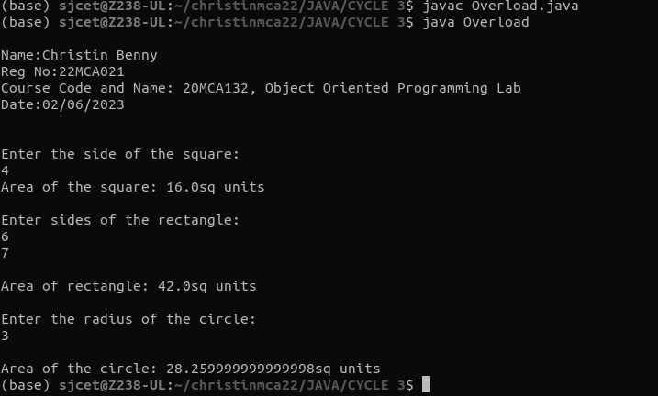

**2. Create a class ‘Employee’ with data members Empid, Name, Salary, Address and constructors to initialize the data members. Create another class ‘Teacher’ that inherit the properties of class employee and contain its own data members department, Subjects taught and constructors to initialize these data members and also include display function to display all the data members. Use array of objects to display details of N teachers.**

**CODE:**

public class Employee{

public static void main(String[] args) {

System.out.println("\nName:Christin Benny\nReg No:22MCA021\nCourse Code and Name: 20MCA132, Object Oriented Programming Lab\nDate:05/06/2023\n\n");

Teacher teacObj[] = new Teacher[2];

teacObj[0]=new Teacher("1","Denzel","Kuzhivelil house",50000,"MCA","DBMS");

teacObj[1] = new Teacher("2","Ashin","Rose House",23000,"MCA","Computer Networks");

teacObj[0].display();

teacObj[1].display();

}

}

class Employees {

String Empid;

String Name;

String Address;

int Salary;

Employees(String id,String name,String addr,int salary){

this.Empid = id;

this.Name = name;

this.Address = addr;

this.Salary = salary;

}

void display(){

System.out.println("EmpID : " + this.Empid);

System.out.println("Name : " + this.Name);

System.out.println("Address : " + this.Address);

System.out.println("Salary : " + this.Salary);

}

}

class Teacher extends Employees{

String Department;

String Subject;

Teacher(String id,String name,String addr,int salary,String dept,String subj){

super(id,name,addr,salary);

this.Department=dept;

this.Subject=subj;

}

void display(){

System.out.println("************************************ ");

super.display();

System.out.println("Dept Name : " + this.Department);

System.out.println("Subject Name : " + this.Subject);

}

}

**OUTPUT:**

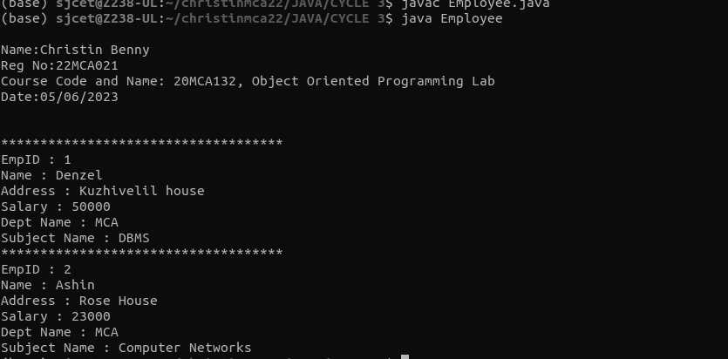

**3. Create a class ‘Person’ with data members Name, Gender, Address, Age and a constructor to initialize the data members and another class ‘Employee’ that inherits the properties of class Person and also contains its own data members like Empid, Company_name, Qualification, Salary and its own constructor. Create another class ‘Teacher’ that inherits the properties of class Employee and contains its own data members like Subject, Department, Teacherid and also contain constructors and methods to display the data members. Use array of objects to display details of N teachers.**

**CODE:**

import java.util.*;

class Person{

String Name;

String Gender;

String Address;

String Age;

public Person(String Name,String Gender,String Address,String Age){

this.Name=Name;

this.Gender=Gender;

this.Address=Address;

this.Age=Age;

}

}

class Employee extends Person {

String Empid;

String Company_Name;

String Qualification;

String Salary;

public Employee(String Name,String Gender,String Address,String Age ,String Empid,String Company_Name, String Qualification,String Salary){

super(Name,Gender,Address,Age);

this.Empid= Empid;

this.Company_Name=Company_Name;

this.Qualification=Qualification;

this.Salary=Salary;

}

}

class Teacher extends Employee{

String Teacherid;

String Department;

String Subject;

public Teacher(String Name,String Gender,String Address,String Age,String Empid,String Company_Name,String Qualification,String Salary,String Teacherid,String Department,String Subject){

super(Name,Gender,Address,Age,Empid,Name,Qualification, Salary);

this.Teacherid=Teacherid;

this.Department=Department;

this.Subject=Subject;

}

public void read(){

Scanner in =new Scanner(System.in);

System.out.println("enter the Name=");

Name=in.nextLine();

System.out.println("enter the Gender=");

Gender=in.nextLine();

System.out.println("enter the Address=");

Address=in.nextLine();

System.out.println("enter the Age=");

Age=in.nextLine();

System.out.println("enter the Employ id=");

Empid=in.nextLine();

System.out.println("enter the Company Name=");

Company_Name=in.nextLine();

System.out.println("enter the Qualification=");

Qualification=in.nextLine();

System.out.println("enter the Salary=");

Salary=in.nextLine();

System.out.println("enter the Teacher id=");

Teacherid=in.nextLine();

System.out.println("enter the Department=");

Department=in.nextLine();

System.out.println("Enter the Subject=");

Subject=in.nextLine();

}

public void display(){

System.out.println("_______Employee Details_________");

System.out.println("Name="+ Name);

System.out.println("Gender=" + Gender);

System.out.println("Address=" + Address);

System.out.println("Age=" + Age);

System.out.println("Empid=" + Empid);

System.out.println("Company Name=" + Company_Name);

System.out.println("Qualification=" + Qualification);

System.out.println("Salary=" + Salary);

System.out.println("Teacher id=" + Teacherid);

System.out.println("Department=" + Department);

System.out.println("Subject=" + Subject);

System.out.println(".........................................");

}

}

class InheritancePerson{

public static void main(String Args[]){

System.out.println("\nName:Christin Benny\nReg No:22MCA021\nCourse Code and Name: 20MCA132, Object Oriented Programming Lab\nDate:05/06/2023\n\n");

int i,n;

Scanner in =new Scanner(System.in);

System.out.println("Enter the Number of employee=");

n=in.nextInt();

Teacher T[] = new Teacher[n];

for(i=0;i<n;i++){

T[i]=new

Teacher("Name","Gender","Address","Age","Empid","Name","Qualification","Salary","Teacherid","Department","Subject");

T[i].read();

}

for(i=0;i<n;i++){

T[i].display();

}

}

}

**OUTPUT:**

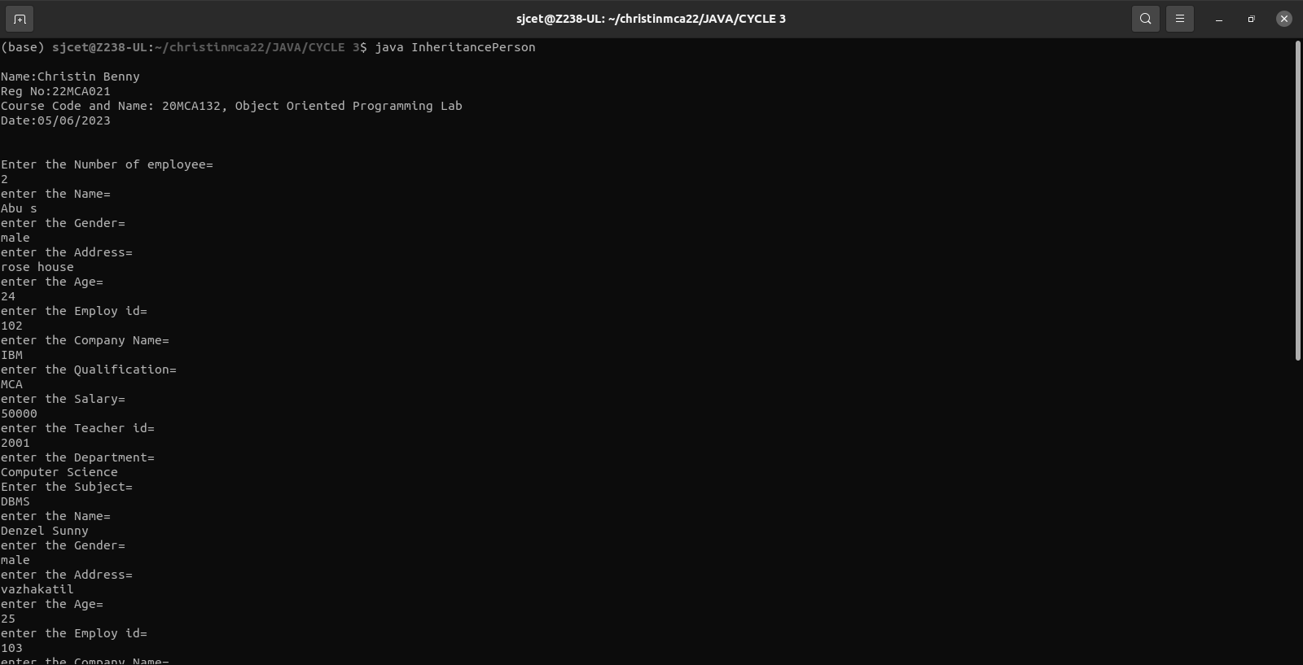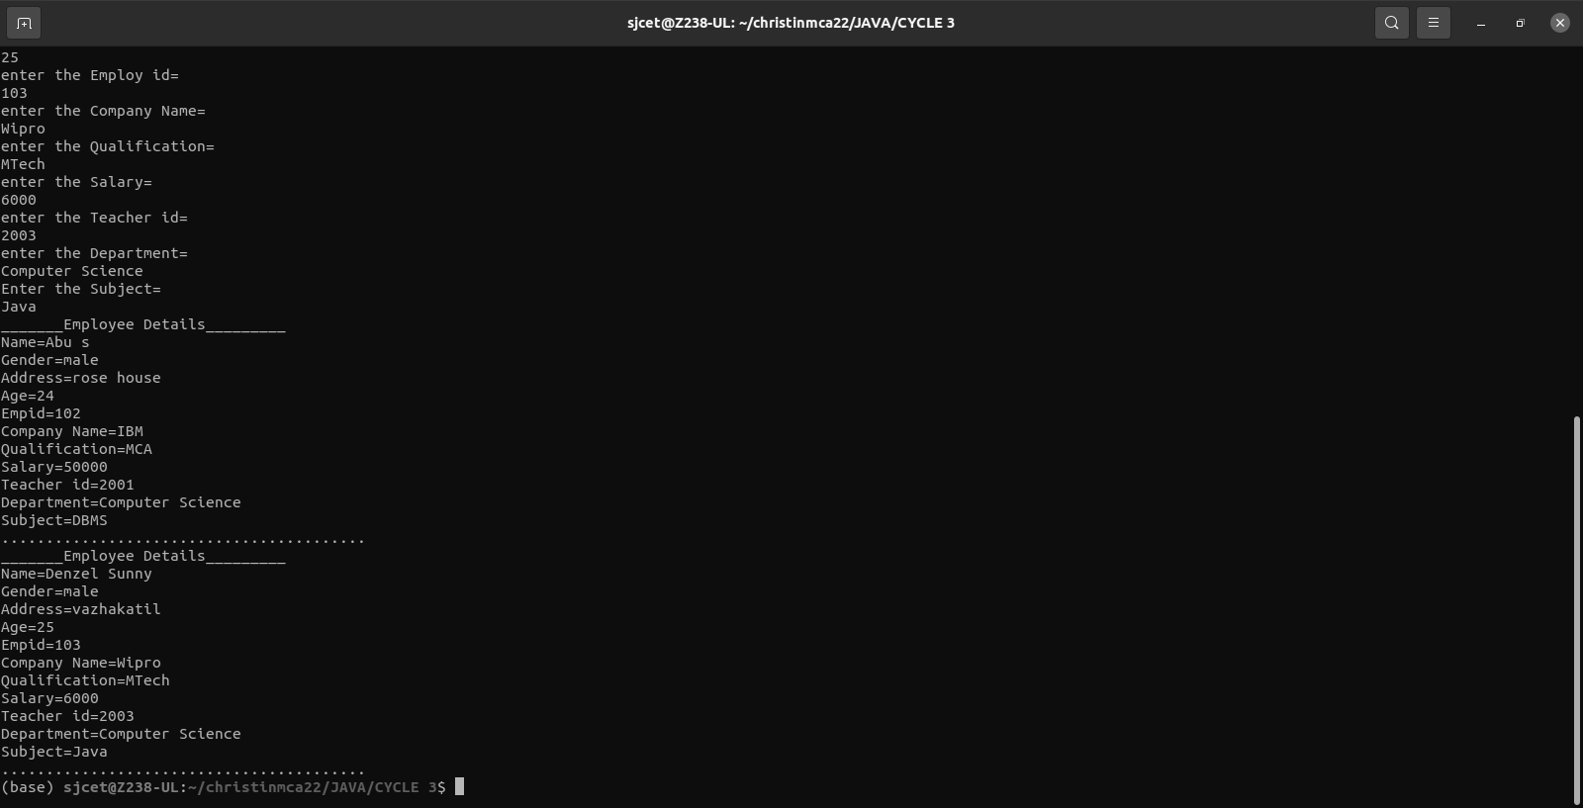

**4. Write a program has class Publisher, Book, Literature and Fiction. Read the information and print the details of books from either the category, using inheritance.**

**CODE:**

import java.util.Scanner;

class Publisher{

String publisher;

Publisher(String pub){

this.publisher=pub;

}

}

class Book extends Publisher{

String book;

Book(String pub,String boo){

super(pub);

book=boo;

}

}

class Literature extends Book{

String category;

Literature(String pub, String boo){

super(pub, boo);

}

void display(){

System.out.println("Publisher :"+publisher);

System.out.println("Book :"+book);

}

}

class Fiction extends Book{

Fiction(String pub, String boo){

super(pub, boo);

}

void display(){

System.out.println("Publisher :"+publisher);

System.out.println("Book :"+book);

}

}

public class bookDetails{

public static void main(String[] args) {

System.out.println("\nName:Christin Benny\nReg No:22MCA021\nCourse Code and Name: 20MCA132, Object Oriented Programming Lab\nDate:07/06/2023\n\n");

System.out.println("\nEnter the No. of Literature Books");

Scanner sc1 = new Scanner(System.in);

int num = sc1.nextInt();

Literature arr[]=new Literature[num];

System.out.println("\n Enter the Literature Book Details\n");

int x = 0,j=0;

Scanner sc =new Scanner(System.in);

for(int i =0;i<num;i++)

{

x = i +1;

System.out.println("\n"+x+")");

System.out.println("\n Book : ");

String boo =sc.nextLine();

System.out.println("\n Publisher: ");

String pub =sc.nextLine();

arr[i]=new Literature(boo,pub);

}

System.out.println("\nEnter the No. of Fiction Books");

int num1 = sc1.nextInt();

Fiction arr1[]=new Fiction[num1];

System.out.println("\n Enter the Fiction Book Details\n");

int x1 = 0,j1=0;

for(int i =0;i<num1;i++)

{

x1 = i +1;

System.out.println("\n"+x1+")");

System.out.println("\n Book : ");

String boo =sc.nextLine();

System.out.println("\n Publisher: ");

String pub =sc.nextLine();

arr1[i]=new Fiction(boo,pub);

}

sc.close();

sc1.close();

System.out.println("\n............Informations of all the Literature Books...............");

for(int i=0;i<num;i++){

j=i+1;

System.out.println("\n"+j+").");

arr[i].display();

}

System.out.println("\n...........Informations of all the Fiction Books.............");

for(int i=0;i<num1;i++){

j1=i+1;

System.out.println("\n"+j1+").");

arr1[i].display();

}

sc1.close();

}

}

**OUTPUT:**

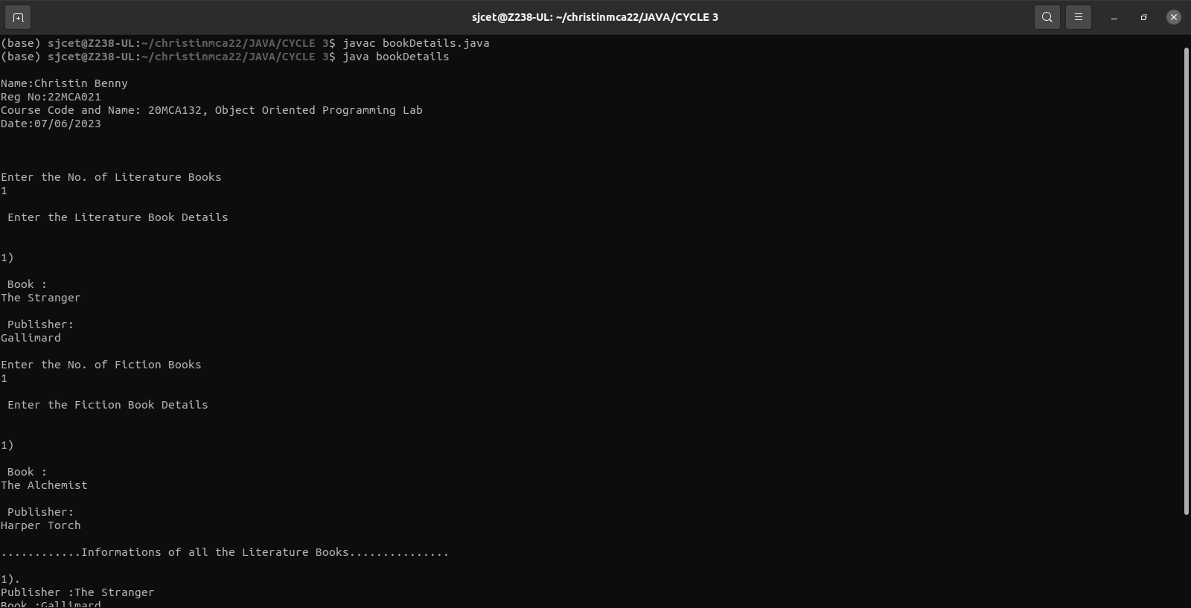

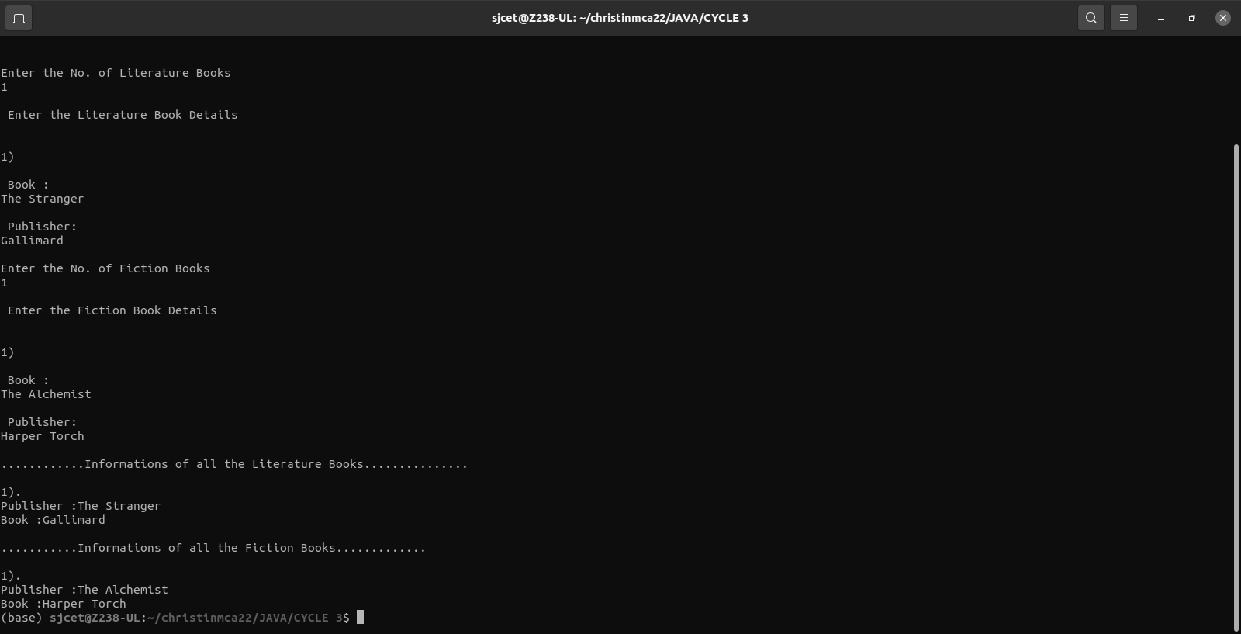

**5. Create classes Student and Sports. Create another class Result inherited from Student and Sports. Display the academic and sports score of a student.**

**CODE:**

**OUTPUT:**

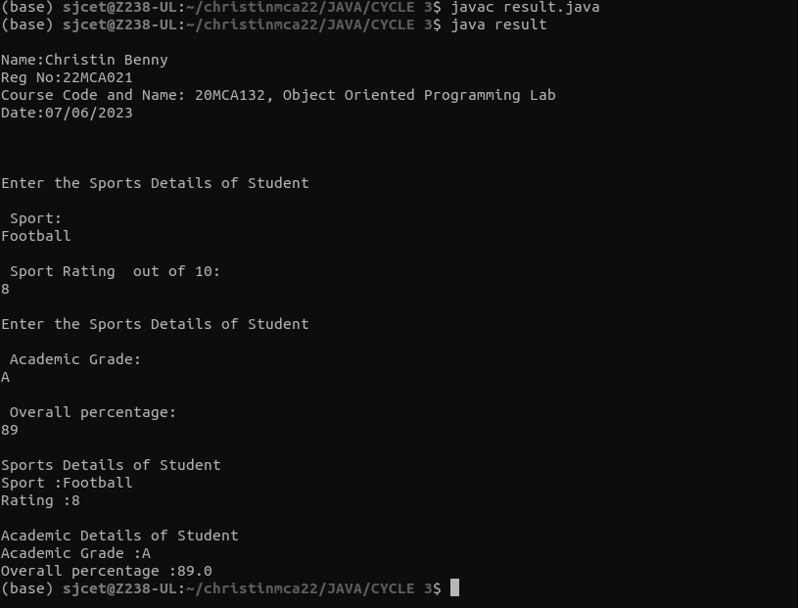

**6. Create an interface having prototypes of functions area() and perimeter(). Create two classes Circle and Rectangle which implements the above interface. Create a menu driven program to find area and perimeter of objects.**

**CODE:**

import java.util.Scanner;

interface prop

{

void getdata();

void area();

void perimeter();

}

class Circle implements prop

{

double pi = 3.14;

double r;

Scanner sc = new Scanner(System.in);

@Override

public void getdata()

{

System.out.println("Enter the radius of the circle:");

r = sc.nextDouble();

}

@Override

public void perimeter()

{

System.out.println("Perimeter of the circle: "+(2*pi*r));

}

@Override

public void area()

{

System.out.println("Area of the circle: "+(pi*r*r));

}

}

class Rectangle implements prop

{

double l,b;

Scanner sc = new Scanner(System.in);

@Override

public void getdata()

{

System.out.println("Enter the length of the rectangle:");

l = sc.nextDouble();

System.out.println("Enter the breadth of the rectangle:");

b = sc.nextDouble();

}

@Override

public void area()

{

System.out.println("Area of a rectangle: "+(l*b));

}

@Override

public void perimeter()

{

System.out.println("Perimeter of a rectangle: "+(2*(l+b)));

}

}

public class Menudriven

{

public static void main(String[] args)

{

System.out.println("\nName:Christin Benny\nReg No:22MCA021\nCourse Code and Name: 20MCA132, Object Oriented Programming Lab\nDate:07/06/2023\n\n");

int ch;

Scanner sc = new Scanner(System.in);

Circle ob = new Circle();

Rectangle obj = new Rectangle();

do

{

System.out.println("\n1.Circle\n2.Rectangle\n3.exit");

System.out.println("Enter your choice:");

ch = sc.nextInt();

switch(ch)

{

case 1 :ob.getdata();

ob.area();

ob.perimeter();

break;

case 2 :obj.getdata();

obj.area();

obj.perimeter();

break;

case 3 :System.out.println("Exited...");

System.exit(0);

}

}while(true);

}

}

**OUTPUT**

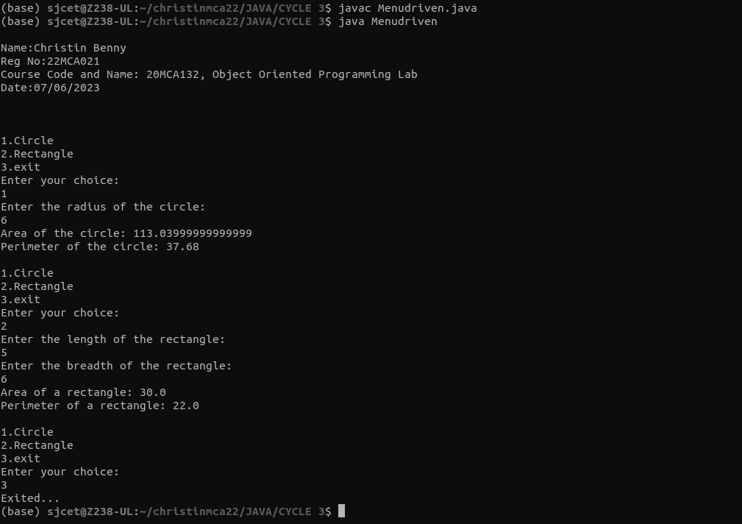

**7. Prepare bill with the given format using calculate method from interface.**



**CODE:**

import java.util.Scanner;

interface calc

{

void calculate();

}

class bill implements calc

{

String date,name,p_id;

int quantity;

double unit_price,total,namount=0;

Scanner sc = new Scanner(System.in);

public void getdata()

{

System.out.println("\nEnter product id:");

p_id = sc.nextLine();

System.out.println("Enter product name:");

name = sc.nextLine();

System.out.println("Enter the Quantity:");

quantity = sc.nextInt();

System.out.println("Enter the unit price:");

unit_price = sc.nextDouble();

}

@Override

public void calculate()

{

total = quantity * unit_price;

}

public void display()

{

System.out.println(p_id+"\t\t"+name+"\t\t"+quantity+"\t\t"+unit_price+"\t"+total);

}

}

public class Ebill

{

public static void main(String[] args)

{

System.out.println("\nName:Christin Benny\nReg No:22MCA021\nCourse Code and Name: 20MCA132, Object Oriented Programming Lab\nDate:07/06/2023\n\n");

int n,i;

double namount=0,t;

int ran;

String date;

t = Math.random() *1000000;

ran = (int) t;

Scanner sc = new Scanner(System.in);

System.out.println("Order no. #"+ran);

System.out.println("Enter the date:");

date = sc.nextLine();

System.out.println("Enter how many products are there:");

n = sc.nextInt();

bill ob[] = new bill[n];

for(i=0;i<n;i++)

ob[i] = new bill();

for(i=0;i<n;i++){

ob[i].getdata();

ob[i].calculate();

}

System.out.println("Date:"+date);

System.out.println("Product Id \tName\t Quantity\t unit price\t Total ");

System.out.println("--------------------------------------------------------------");

for(i=0;i<n;i++){

ob[i].display();

namount += ob[i].total;

}

System.out.println("--------------------------------------------------------------");

System.out.println("\t\t\tNet.Amount\t"+ namount);

}

}

**OUTPUT**

